🔹 1. What is Peer Review?
✅ Definition
Peer Review is the process where one or more developers review another developer’s code before it is merged into the main codebase.
👉 It is usually done via Pull Requests (PRs) in tools like GitHub, GitLab, or Bitbucket.

🎯 Why do we use Peer Review?
Reason | Explanation
Improve Code Quality | Catches bugs, bad logic, anti-patterns
Knowledge Sharing | Team learns each other’s code
Enforce Standards | Ensures coding guidelines are followed
Reduce Defects | Issues caught early → cheaper to fix
Build Team Ownership | Code belongs to team, not individual

🔄 How Code Behaves Before Peer Review
❌ Problems:
- Logical bugs unnoticed
- Code smells (long methods, duplicate code)
- Hard-coded values
- Poor naming conventions
- No unit tests
Example (Before Review):
public int cal(int a, int b) {
return a + b * 10;
}
❌ Issues:
- Method name unclear
- No validation
- No documentation

🔄 How Code Behaves After Peer Review
✅ Improvements:
- Clean naming
- Better readability
- Validation added
- Logic clarified
- Tests written
Example (After Review):
/**
* Calculates total salary including bonus
*/
public int calculateTotalSalary(int baseSalary, int bonus) {
if (baseSalary < 0 || bonus < 0) {
throw new IllegalArgumentException("Salary values cannot be negative");
}
return baseSalary + (bonus * 10);
}
✅ Result:
- Clear intent
- Safer code
- Maintainable

🔹 2. What is a Code Review Checklist?
✅ Definition
A Code Review Checklist is a standard list of items reviewers verify before approving a Pull Request.
It acts as a quality gate.

📋 Typical Code Review Checklist (Java Focused)
🧠 Logic & Functionality
- Does the code meet requirements?
- Are edge cases handled?
- Any hidden bugs?
🧹 Code Quality
- Proper naming (classes, methods, variables)?
- No unused variables/imports?
- Methods not too long?
🧩 Design & Architecture
- Follows SOLID principles?
- No tight coupling?
- Proper layering (Controller → Service → Repository)?
🔐 Security
- No hard-coded credentials?
- Input validation done?
- Sensitive data not logged?
🧪 Testing
- Unit tests added?
- Existing tests passing?
- Edge cases covered?
⚙️ Performance
- No unnecessary loops?
- Proper collections used?
- Avoid expensive DB calls in loops?

🎯 What Does a Checklist Do for Us?
Benefit | Explanation
Consistency | Every PR reviewed the same way
Faster Reviews | Reviewers know what to check
Fewer Misses | Reduces human oversight
Training Tool | Helps juniors learn standards

🔹 3. Pull Request (PR) – Explained Simply
✅ What is a Pull Request?
A Pull Request is a request to merge your code from one branch into another, usually:
feature-branch → main / develop
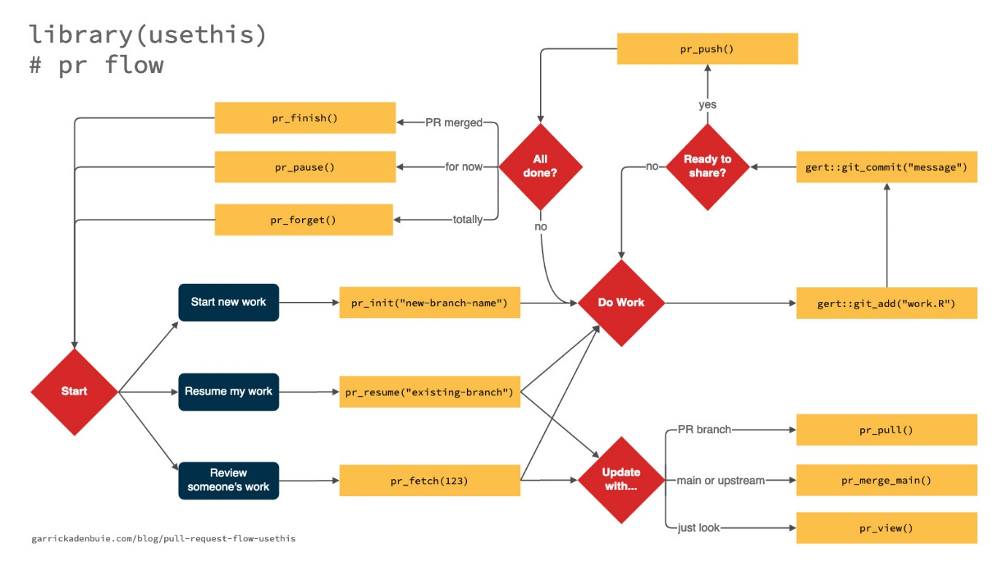
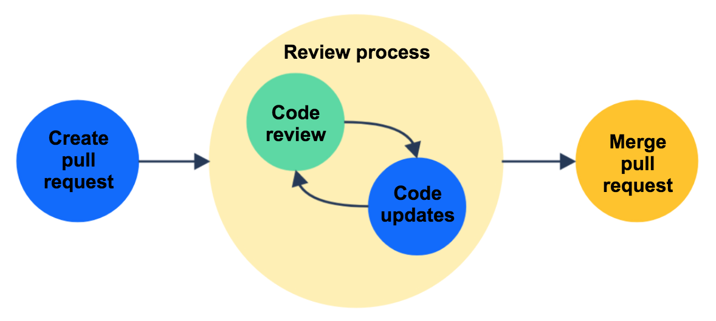
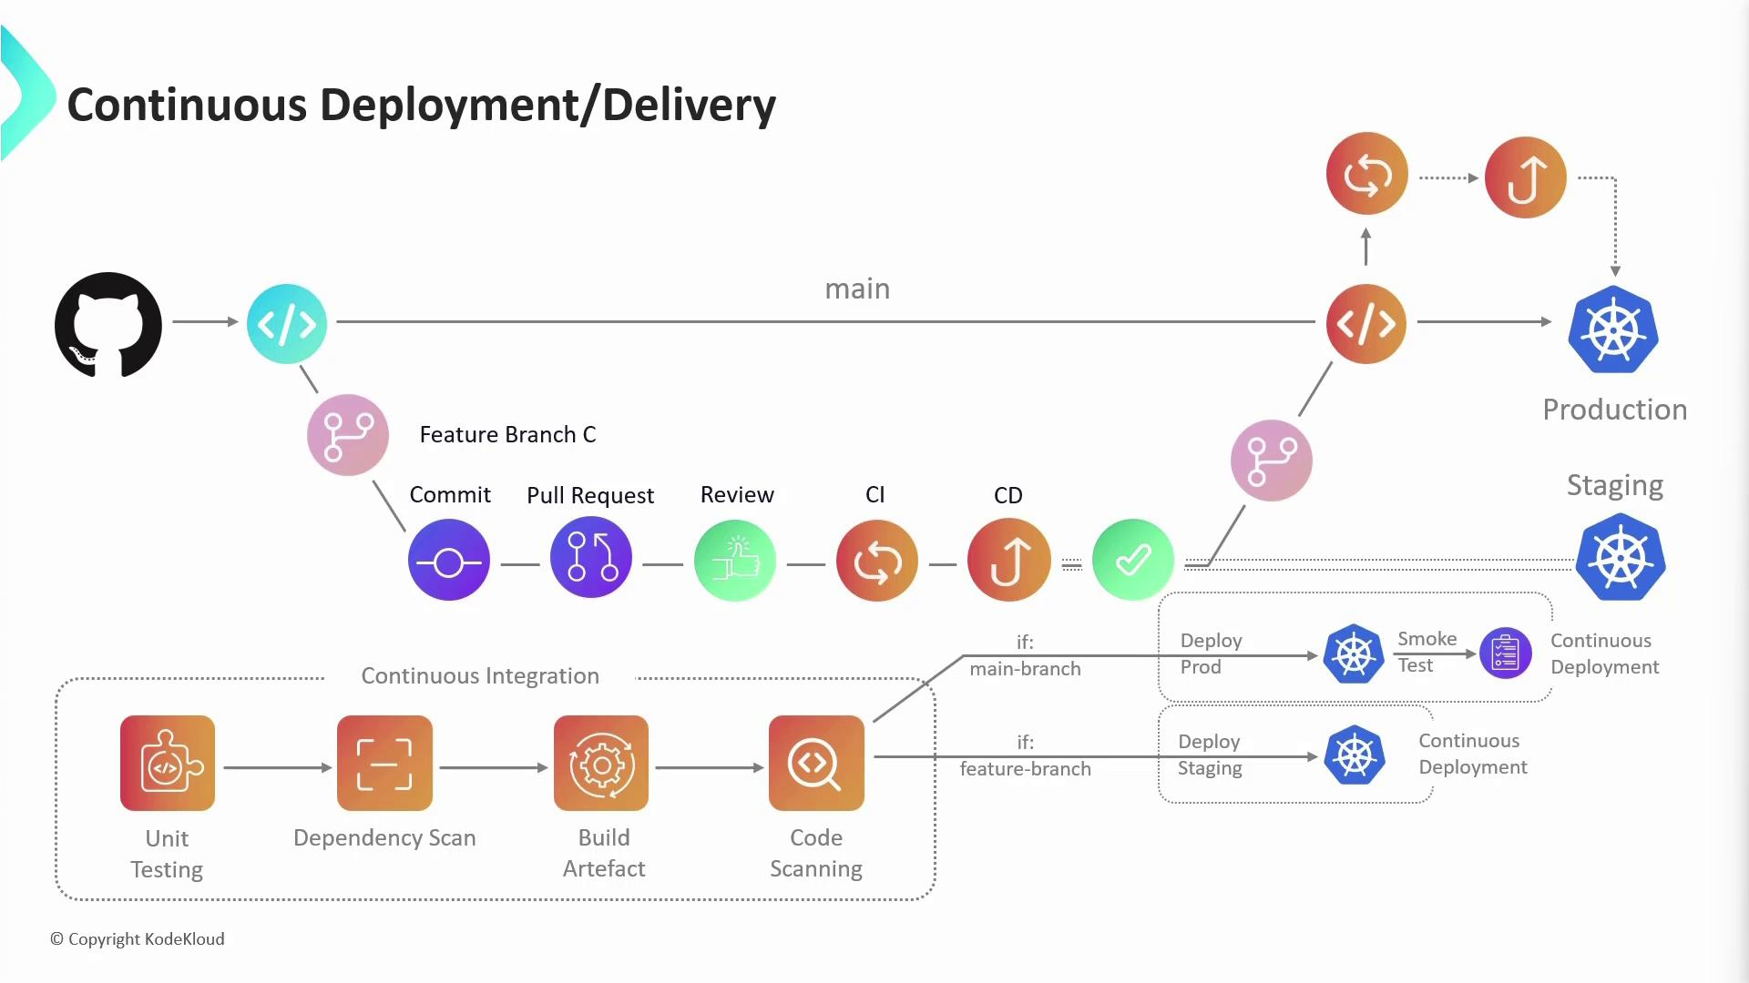

🧠 Pull Request Best Practices
🟢 1. Keep PRs Small
❌ Bad:
- 3,000 lines
- Multiple features mixed
✅ Good:
- One feature / one bug
- Easy to review

🟢 2. Write a Clear PR Description
Good PR Description Example:
Feature: Employee Salary Calculation

Changes:
- Added salary calculation logic
- Added validation
- Added unit tests

Related Ticket: JIRA-102

🟢 3. Self-Review Before Raising PR
✔ Run tests
✔ Check formatting
✔ Remove debug logs

🟢 4. Respond to Review Comments Properly
- Don’t take feedback personally
- Ask questions if unclear
- Fix and reply politely

🟢 5. Do Not Merge Your Own PR
✔ At least one reviewer approval
✔ CI pipeline must pass

🔹 4. Continuous Integration (CI) – Basics
✅ What is Continuous Integration?
Continuous Integration (CI) is the practice of automatically building, testing, and analyzing code whenever a change is pushed.

⚙️ What Happens in CI?
When you create a PR:
- Code is pulled
- Build starts
- Unit tests run
- Static analysis (Checkstyle, PMD, SpotBugs)
- Coverage check (JaCoCo)
- Result shown in PR

🧪 Example CI Flow (Java + Maven)
mvn clean verify
This runs:
- Compilation
- Tests
- Code quality checks
- Coverage

🎯 Benefits of CI
Benefit | Explanation
Early Bug Detection | Errors caught immediately
Safer Merges | Only green builds allowed
Faster Delivery | Automation saves time
Better Quality | Enforced standards

🔹 5. Peer Review + PR + CI (Together)
🧠 Real-World Flow
- Developer writes code
- Pushes to feature branch
- Raises Pull Request
- CI pipeline runs automatically
- Reviewer checks PR using checklist
- Issues fixed
- PR approved
- Code merged safely
✅ Result: High-quality, production-ready code

